**COMP804 – ASSESSMENT TASK 3 –ASSIGNMENT 1**

**Student Name: Fan Kiu (Frankie) Mak and Student ID: 8730611**

**Task 5** – Github Repository Report for details of Task 1-4 instructions on uploading the source code to a GitHub repository

**Step 1: Create a GitHub Account**

1. Go to https://github.com/

2. Click "Sign up" and follow the prompts to create an account.

**Step 2: Install Git**

1. Download Git from https://git-scm.com/downloads

2. Install Git, following the installation wizard.

**Step 3: Configure Git**

Open a terminal or command prompt and run:

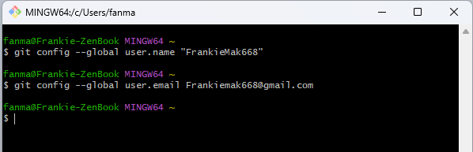

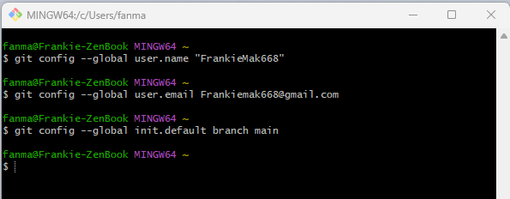

**Step 4:** **Initialized repository**

Look at the internal computer folder for uploading to the GitHub Repository

change the terminal directory to look at where those files and the initialized repository are.

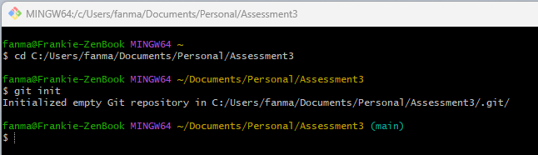

**Step 5:** **Create a New** **Repository on GitHub**

1. Log in to GitHub

2. Click the "+" icon in the top-right corner and select "New repository"

3. Create the Name of the repository (i.e., " Assessment3 ")

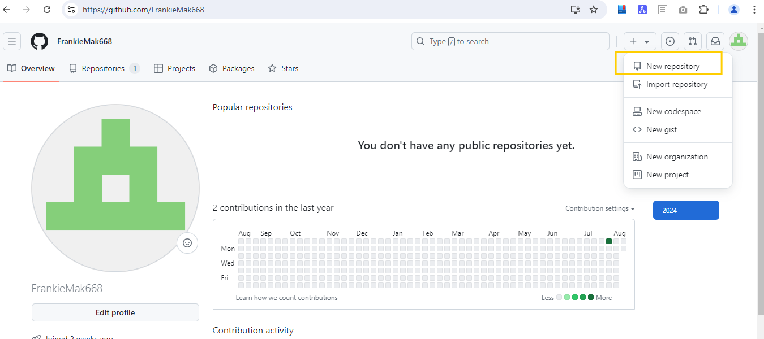

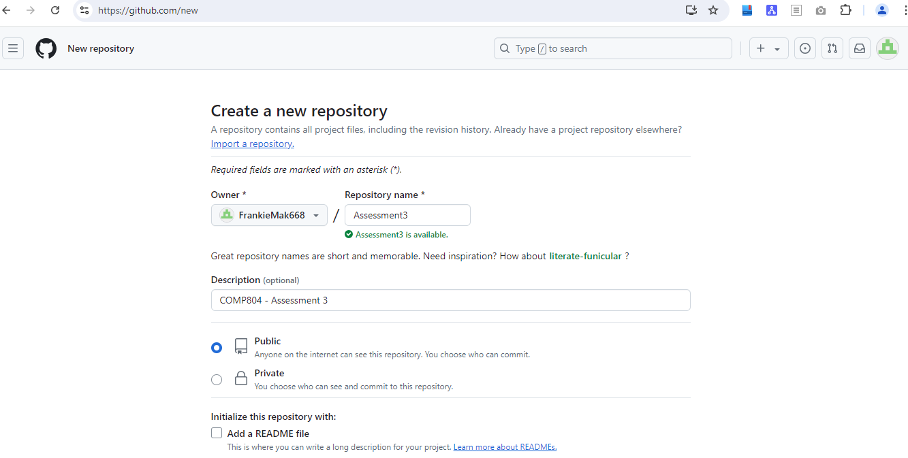

4. Choose "Public" visibility

5. Click "Create repository"

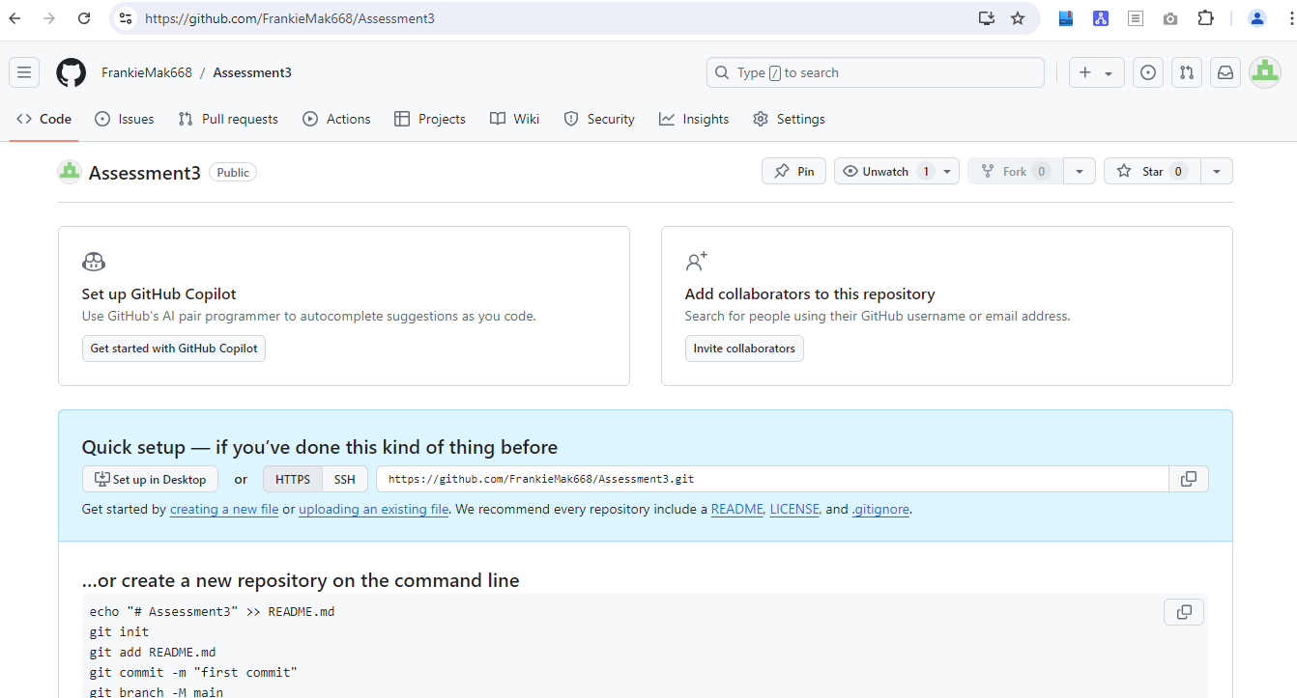

**Step 6: Clone the Repository Locally**

1. On the repository page, click the "Code" button and copy the HTTPS URL

<https://github.com/FrankieMak668/Assessment3.git>

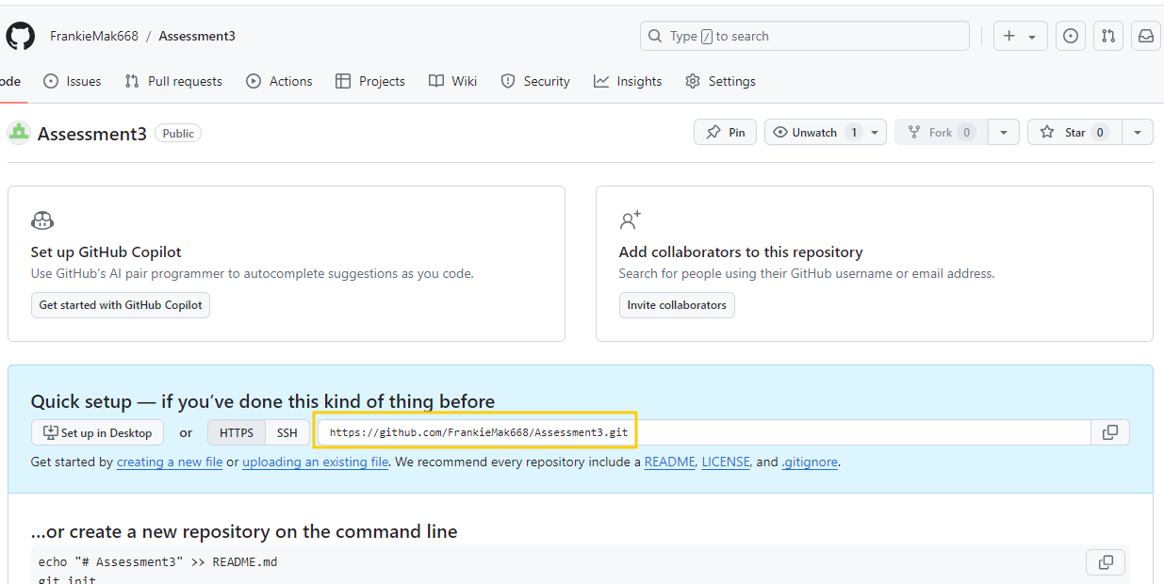

2. Open a terminal or command prompt

3. Check status:

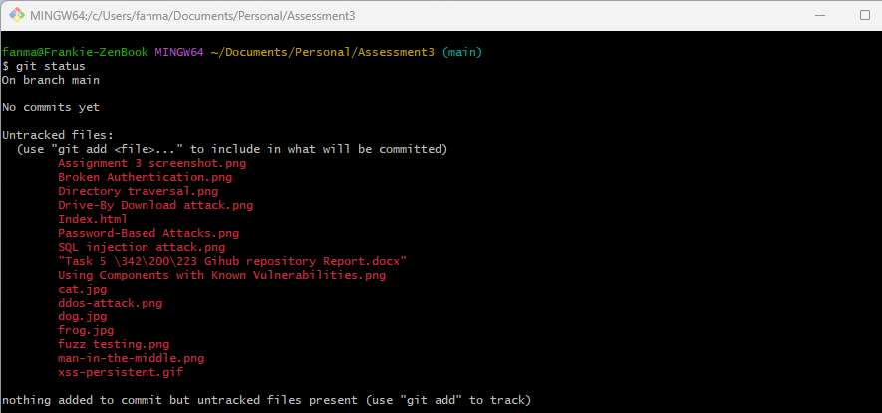

**Step 7. Staging - Add folder files that are on track.**

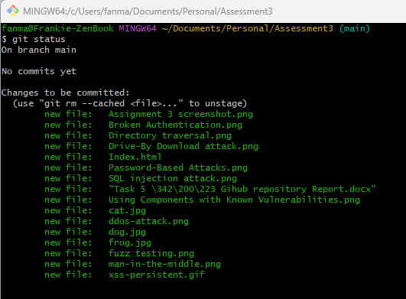

**Step 8. Committing all files to the repository - Git commit -m "first commit."**

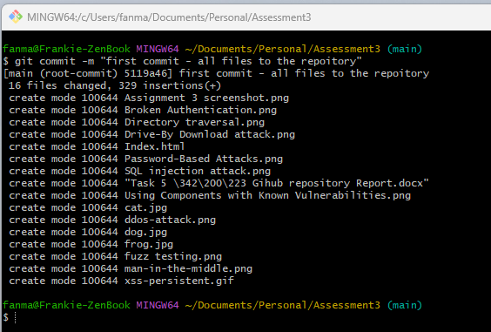

**Step 9. Push the local folder to the GitHub**

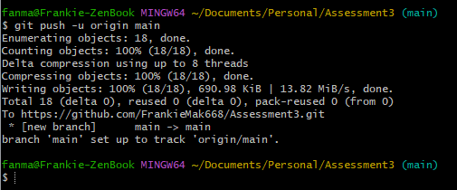

Push all file Changes to GitHub

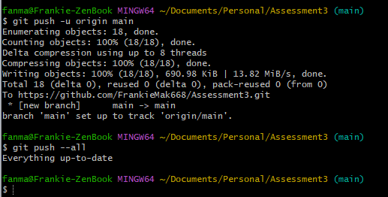

The above Screenshot shows that the command "all files" the pushing process has been done (update in Github server).

**Step 10: Verify Your Upload**

1. Go to the GitHub repository page in the web browser

2. Refresh the page

3. The files listed in the repository

Now, we can go to our GitHub repository to check whether the file appears.

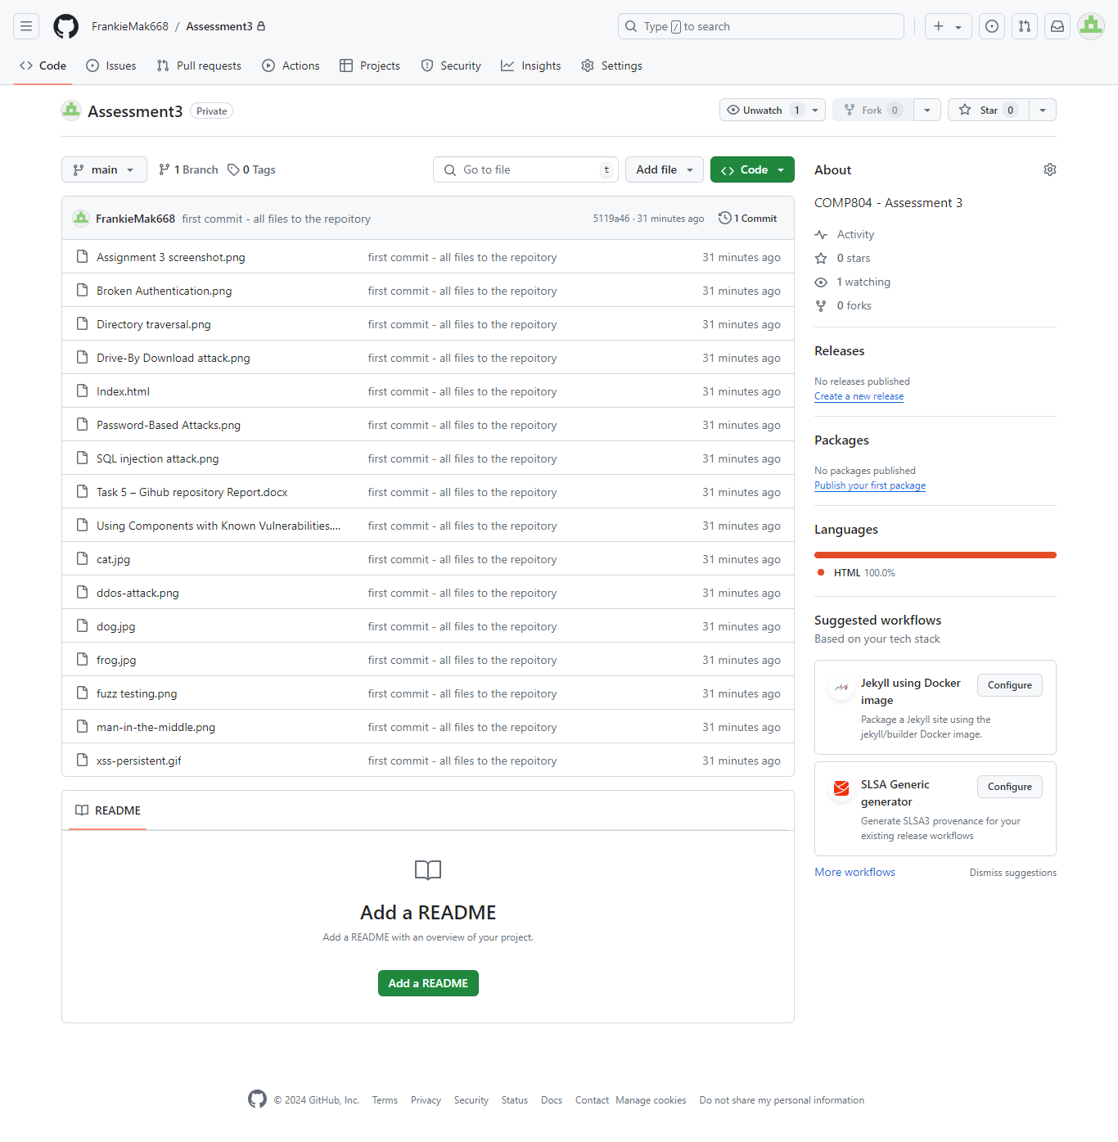

**Step 11: Submit Assessment 3 GitHub Repository URL**

Below is the URL of the Assessment 3 GitHub repository to be accessible for marking.

<https://github.com/FrankieMak668/Assessment3.git>